Rosetta Stone

Really an immersive learning process or well marketed waste of time?

Rosetta Stone is a leading software for learning foreign languages from scratch. Although it has achieved a lot of success, it has drew heck lot of criticism from experts of languages as well. This software, available at a staggering price of $500 claims to provide a learning experience similar to that of learning your first language. For some, this software has worked fantastically, but some can’t even learn to form a simple sentence in the language they are learning. Because of it’s price of $500, most of the people hesitate to buy the product. But go nowhere. Because I have used this software to learn a foreign language, I can tell you the pros and cons of using Rosetta Stone.

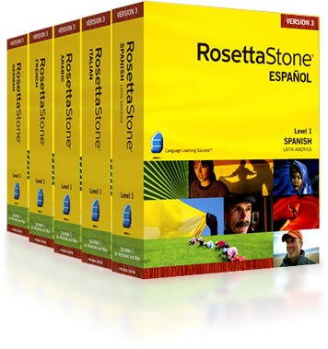

What does Rosetta Stone offer?

Rosetta Stone offers more than 30 languages to learn and try to emulate innovative methods that were proved successful on many individuals. Rosetta Stone use their own technique called the ‘Total Immersion’ approach, which has given them the edge above others. With a simple layout, pictures and audio, Rosetta Stone provides a beautiful environment to learn a new language.

Content

Rosetta stone comes with a lot of additional extras. And at this rate, you would expect them! Along with the software, Rosetta stone provides audio-visual CDs along with a USB headset which comes with lots of settings regarding the reception of sound. The voice recognition is not bad and picks up on subtle mistakes. Although at some points, the software lacks in precise vocal recognition. There are three to five levels to learn a language. The courses are well structured that helps you to stay on track. And also because of the style of teaching, there is a strong interconnectedness to the whole method of learning.

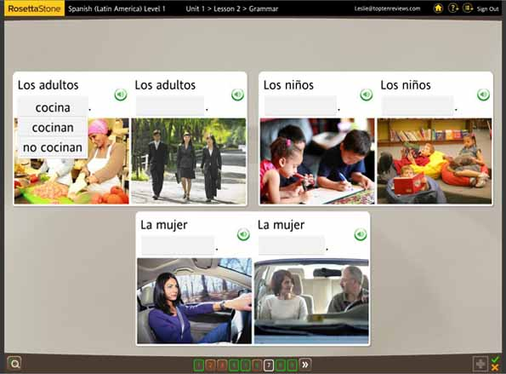

Usability

Because Rosetta stone is geared up to utilize the way we learn as children, it is a very effective study aid for those who are younger. However, as an adult, it is difficult to whether this program will be of any help or not. There is an argument that Rosetta Stone programs are just glorified flashcards, and to an extent that is absolutely true. But I am not saying that it won’t work. These flash cards help you to jump into the content spontaneously. However, if you are one of those people who need to know the science behind the stuff, then this course isn’t for you. The main reason behind this is, that Grammar is not given much importance whatsoever, beyond you figuring out yourself. You are expected to learn to associate what you say to what is in front of you and remember its pronunciation. This also has some drawbacks, but with updates, experts at Rosetta Stone try to solve them. Overall, the pace of lessons is excellent, with lot of recapping previous points and making sure that you understand the right lessons that have been taught. It is focused mainly on the vocabulary and not on the grammar. Because of that, even at the end of your course, you might not be able to form complex sentences yourself. So, it is not a course you can take up in few weeks. It definitely requires you to ‘immerse’ yourself into the program as they say it!

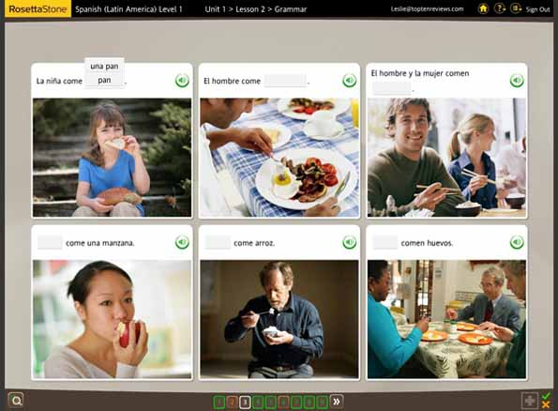

Conclusion

Make no mistake. If Rosetta stone works for you, it is going to work fantastically. The biggest flaw that lies is that this sort of learning doesn’t appeal to everyone, and not everyone can learn a language properly with this course. As the program is made in a way that you learn the way the children learn, this program fails for certain individuals. The way we learn as children is completely different to the way we learn as adults. We cannot process the information in the same open-minded way that we do as children.

This is the reason I won’t recommend this course to everyone. It is very specific in design that even if there’s a little thing not working for you, the entire program won’t help. Also it is a heck lot of money to spend and check whether it is for you or not. Still, if you are confident that you have the same open-minded thinking like that of children, Rosetta Stone will work like a charm for you!